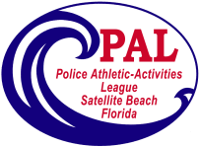
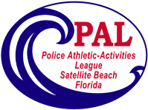
Satellite Beach PAL Volleyball
Girls ages 10-16
Spring 2026
Registration Begins January 20, 2026
Skill Assessments February 22, 2026 @2:00pm
Practices begin March 10, 2026
Games Begin on Saturday March 29, 2026
Photos by Skip Combs TBA

The season begins March 29, 2026
Playoffs begin May 10 or 12, 2026
Final Championship Game – May 16, 2026
The cost for this season is $100
Need more information, please contact us at:
321-777-8336
Pal@satellitebeach.org

